Proposal: Modernization of the JSON-Based Test Harness
Let me start with something slightly lighter: we all love tests — especially when they pass. We love them a little less when they fail. And we love them even less when they pass… but shouldn’t have. This proposal is about moving from 'it seems fine' to 'it is structurally correct, observable, deterministic, and semantically accurate.'
In this document, I walk through the evolution from our current JSON test harness to the new modern harness. I will show practical evidence using the exact screenshots captured during analysis, explain the structural limitations of the old approach, and demonstrate how the new harness addresses them through architectural improvements.

Pillar 1 – Accurate Test Count & Reporting Integrity
Old Harness – Incorrect or inaccurate test count representation:

Old Harness Test Results
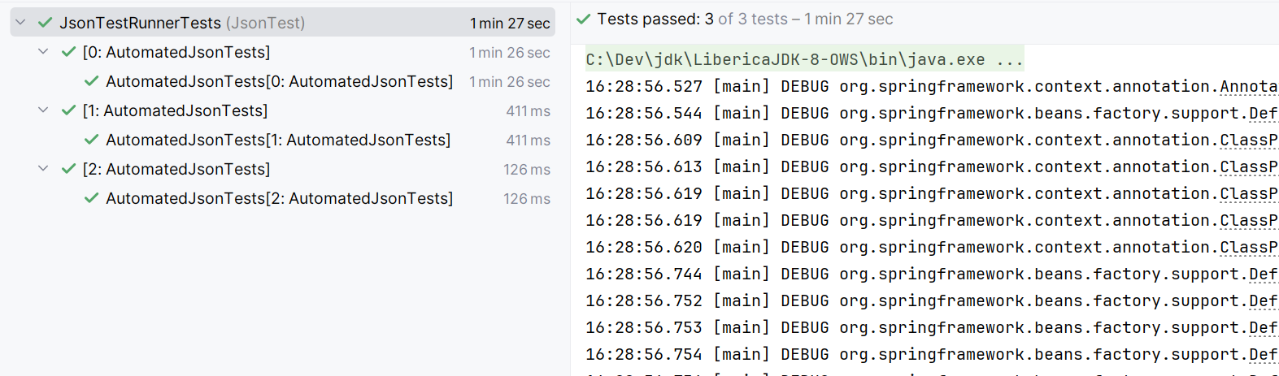
In the old harness, JUnit reports wrapper-level test counts rather than true scenario counts. Tests are nested inside a generic wrapper such as AutomatedJsonTests. This flattens visibility and hides real execution units. When testing ODD79 with the current harness, it reported 127 tests, this is not accurate, the total tests count is 616 (this are test cases), but the current harness says 127.

New Harness – Correct Scenario-Level Reporting:

New Harness Test Results
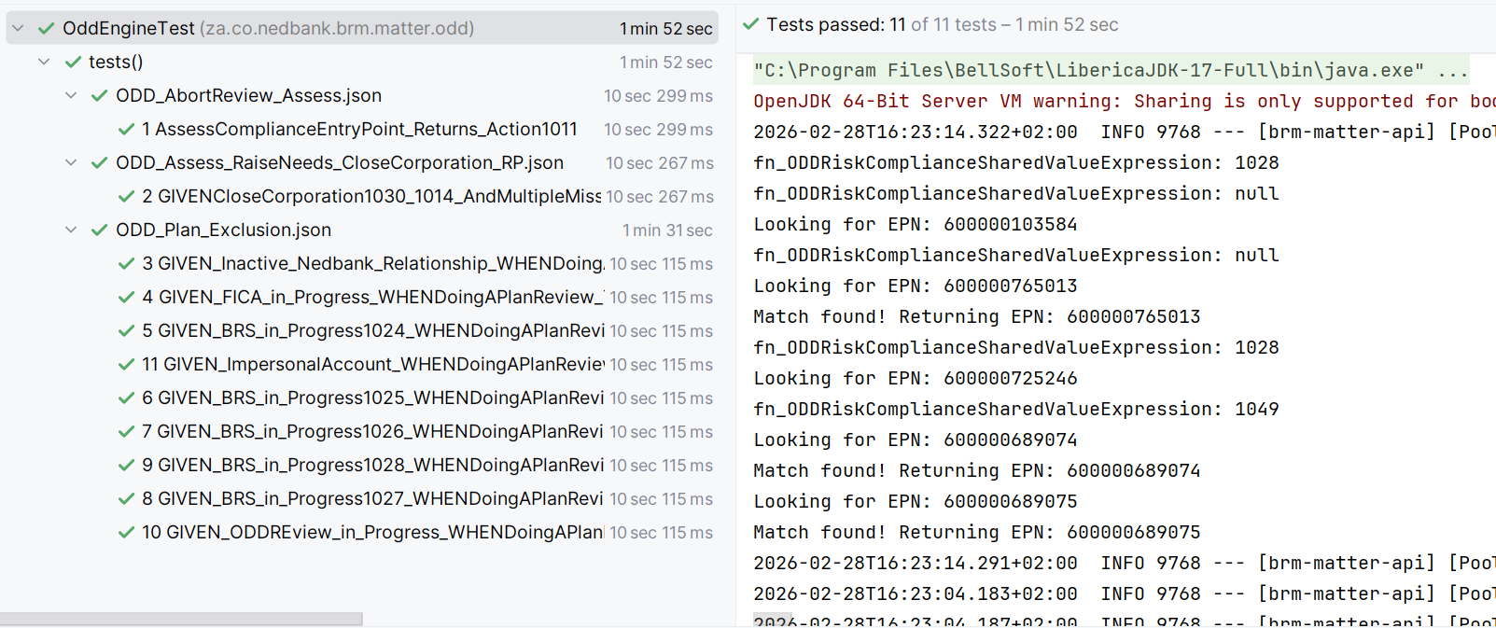
In the new harness, each JSON scenario is registered as a first-class JUnit test. JUnit reports the exact number of executable scenarios, improving metric integrity and CI visibility.

Pillar 2 – Structured Failure Diagnostics
Old Harness Failure View:

Old Harness Failure Display
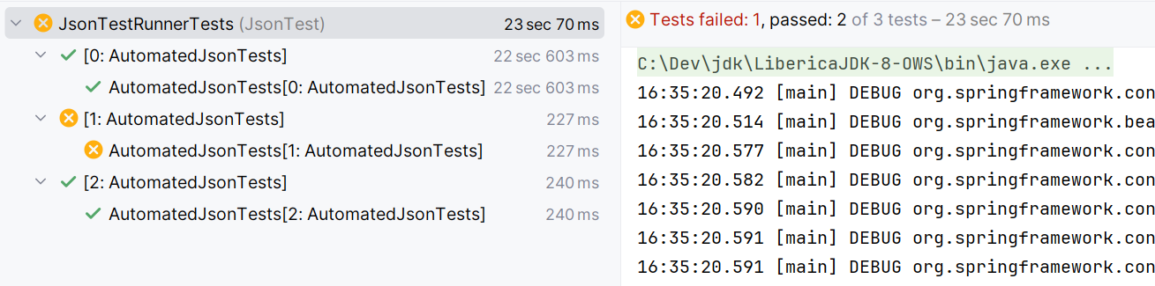
Failures appear under generic test names. Business context is buried within stack traces. Developers must scroll through debug noise to identify the root cause.

New Harness Failure View:

New Harness Failure Display
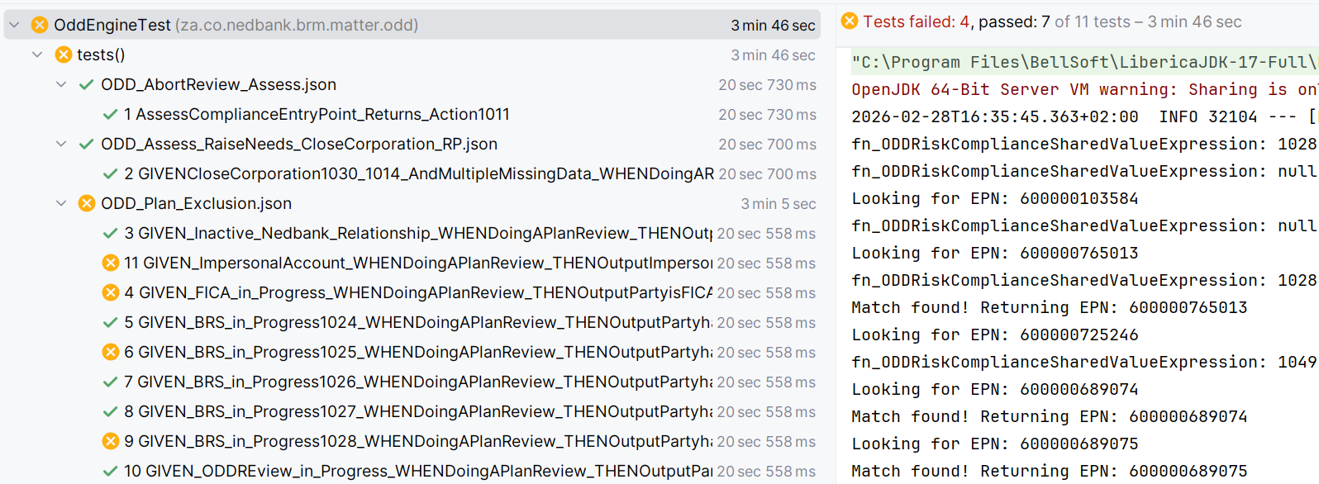
Failures are grouped by JSON file and scenario name. Business-readable BDD-style names immediately identify which rule failed.

Pillar 3 – Structured Assertion Engine

Old Failure Detail
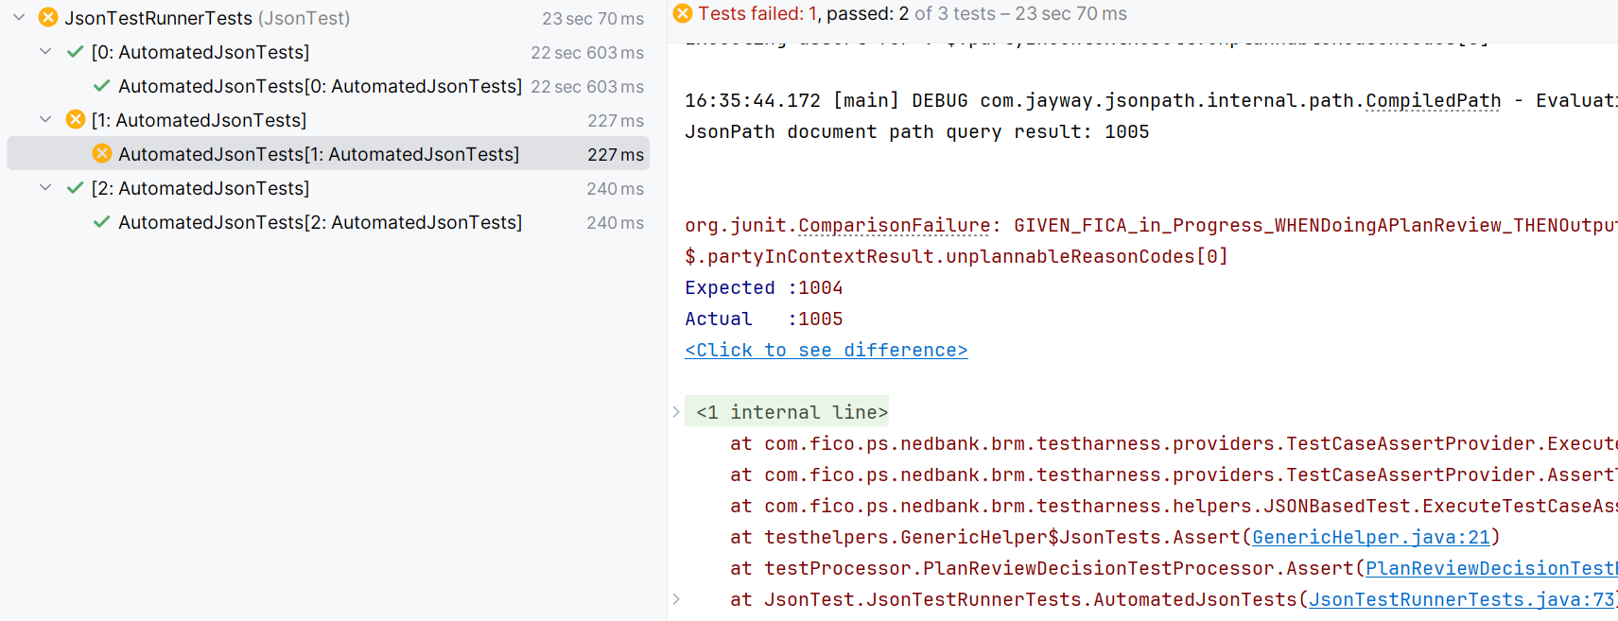
The old harness relies on JUnit ComparisonFailure with implicit coercion of JsonPath results. Scalar vs list differences are silently normalized. I will talk more on this later as it is the major problem I discovered.

New Failure Detail
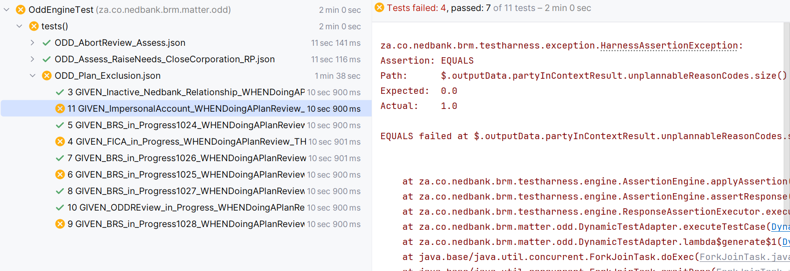
The new harness introduces a structured AssertionEngine with explicit operators and controlled evaluation semantics. No silent scalar coercion occurs.

Pillar 4 – Hierarchical Specification - Driven Execution

Old Full Test Run
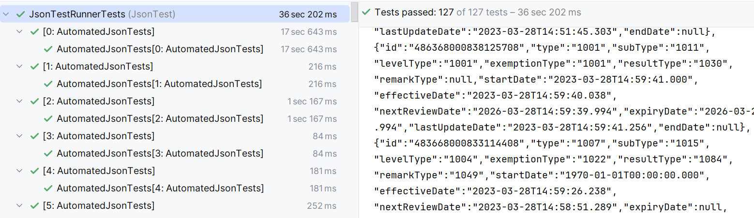
The old harness presents a flat execution model. JSON files and domain grouping are not visible. Also the test report is 127 which is incorrect.

New Full Test Run
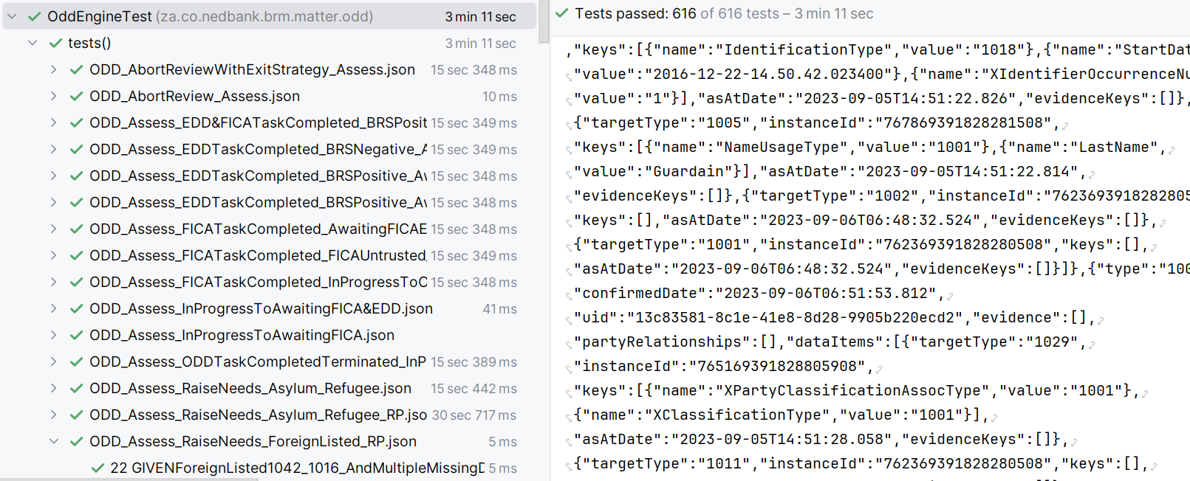
The new harness groups tests by JSON specification and scenario, improving traceability, maintainability, and domain alignment.

Pillar 5 – Automatic Failure Replay Artifact Generation

Generated Failure Report File
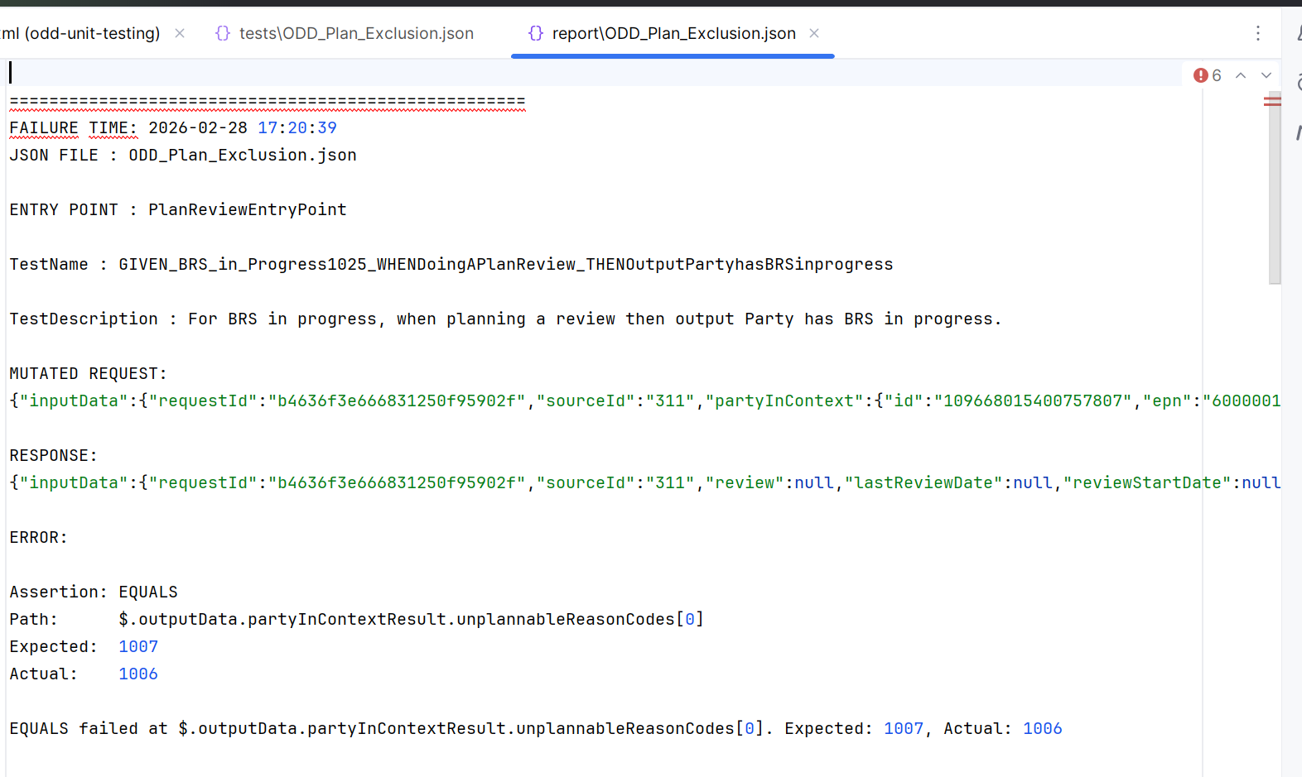
When a test fails, the new harness generates a structured failure report file containing mutated request, response, assertion type, JSON path, expected and actual values. This eliminates manual mutation during debugging and drastically reduces Mean Time To Resolution. We have to do manual mutation of a request when there is a failure to reproduce the error before running it against the service for debug purposes. This is time consuming.

Pillar 6 – JsonPath Semantic Accuracy & Transparency

JsonPath Filter Example
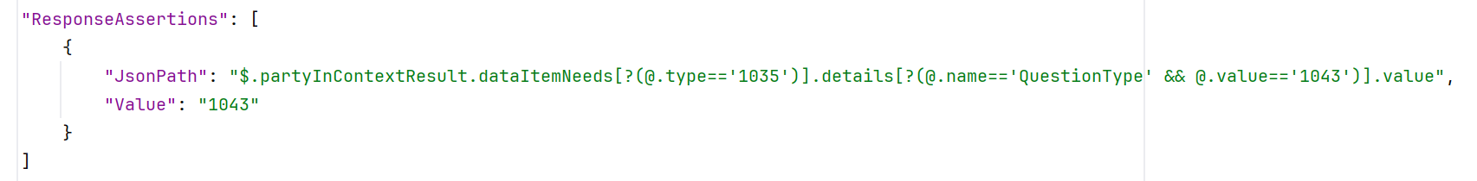

JsonPath Simple Example
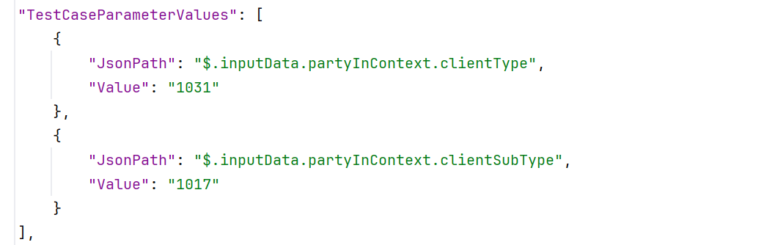
I discovered that filtered JsonPath expressions return arrays, while direct field access returns scalars. The old harness masked this difference. The new harness preserves evaluation semantics, reducing the risk of semantically incomplete validations.

Pillar 7 – Intent-Based Assertion Operators
The new harness introduces an AssertionOperator enum with operators such as EQUALS, CONTAINS, EXISTS, ARRAY_SIZE, PARTIAL_EQUALS, and ARRAY_CONTAINS_PARTIAL. This mirrors AssertJ-style expressiveness and separates navigation (JsonPath) from semantic intent.
This reduces reliance on complex Jayway filter expressions and allows clearer, more maintainable test specifications. It also enables future expansion (e.g., REGEX_MATCH, BETWEEN, JSON_SCHEMA_MATCH) without rewriting existing tests.

Pillar 8 – Parallel Execution & High-Performance Regression
The new harness leverages JUnit 5 parallel execution. Because services are stateless, scenarios can safely execute concurrently. In practice, 650+ test cases execute in ~20 seconds. This significantly improves CI feedback loops and developer productivity. Ignore the execution times you saw on the screenshots they are not accurate. I am yet to figure out why they are being reported incorrectly.

Pillar 9 – Platform Modernization (Spring Boot 3 & Java 17)

Spring Boot Parent POM
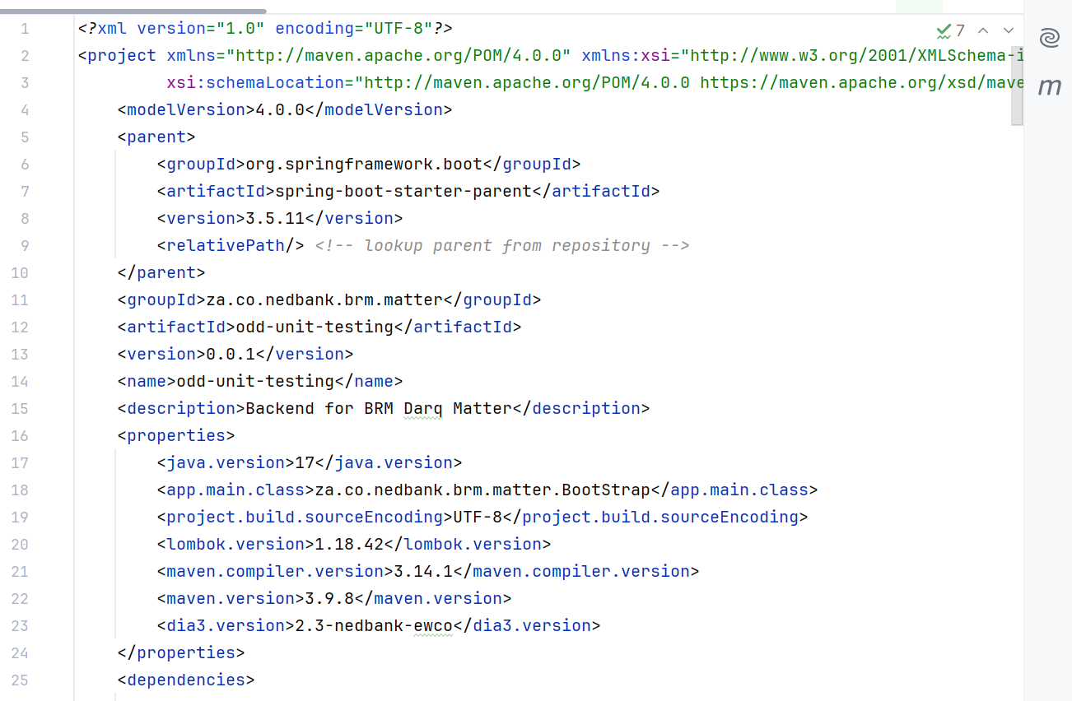
The new harness is built on Spring Boot 3.5.x and Java 17 LTS. Dependency management is handled via Spring Boot’s BOM, eliminating version conflicts between JUnit, Assert libraries, Jackson, and logging frameworks. This reduces maintenance risk and aligns with modern enterprise standards.

Pillar 10 – Clean Architecture & Best Practices
The harness code follows SOLID principles and clean layering. AssertionEngine, ResponseAssertionExecutor, and DynamicTestAdapter are separated by responsibility. Design patterns are used where appropriate to maintain extensibility and testability.

The framework is future-ready, supporting new operators, deeper structural assertions, and potential integration with mutation testing or reporting tools.
Pillar 11: Test Harness as a First-Class Citizen
Our Test Harness is not just a utility — it is foundational infrastructure.
Just as we rigorously test our production code, we must apply the same discipline to the Test Harness itself. A testing framework that is not thoroughly tested introduces hidden risk, false confidence, and unreliable results.
The Test Harness has therefore been tested across all possible scenarios, including:
- Valid success cases
- Failure scenarios
- Edge cases and malformed inputs
- Assertion mismatches
- Path resolution errors
- Unexpected JSON structures
- Exception handling behavior
- Reporting and stack trace formatting
This ensures that:
- The harness behaves deterministically
- Errors are reported clearly and consistently
- Developers receive accurate, actionable feedback
- There is no hidden behavior that only works under ideal conditions
We are not shipping a tool that has been validated only by minimal developer observation or limited happy-path checks. Instead, we are treating the Test Harness as we would treat any production-grade library or framework.
Testing must be treated as a first-class citizen, not as a secondary concern.
By validating the validator, we strengthen the integrity of our entire testing ecosystem.

A Light-Hearted Note (But a Serious Point)
We have an engine that uses a very big request and returns a very big response. The engine is CHC.
I have personally never seen such a request/response in my entire life. I am fairly certain even Google would pause and wonder whether there exists a machine powerful enough to safely open it without crashing — not to mention ordinary text editors.
The only comparable objects of that magnitude I could imagine might be discovered somewhere beyond planet Earth — perhaps retrieved by a Tesla space mission.
On a serious note, I deliberately used an actual CHC response to validate the robustness of the Test Harness. If the harness can correctly process, assert, and report against responses of that scale and complexity — including deeply nested structures and extreme payload sizes — then we can confidently say it has been tested beyond normal operating conditions.
In other words, the harness has been tested not only for earthly scenarios — but even for those that might possibly come from the moon.

Migration Strategy
1. Freeze new tests on the legacy harness.
2. Gradually migrate JSON specifications to the new format.
3. Run both harnesses in parallel temporarily.
4. Validate regression equivalence.
5. Deprecate and remove legacy harness once coverage parity is achieved.

Conclusion
This modernization is not cosmetic. It improves correctness, transparency, performance, maintainability, and governance alignment. It transforms our regression suite into a structured, specification-driven validation platform.

